How to install the Arduino Create Agent :
- https://support.arduino.cc/hc/en-us/articles/360014869820-How-to-install-the-Arduino-Create-Agent

How to uninstall the Arduino Create Agent :

https://support.arduino.cc/hc/en-us/articles/360014869840-How-to-uninstall-the-Arduino-Create-Agent

My experience using Arduino Create Agent on my computer (Windows 10 OS)

After I finished installing the “Arduino Create Agent” on my computer, then I ran it, but I couldn't upload program code from Arduino Web Editor to ESP32. I waited about 5 minutes, but the program code still hasn't been uploaded to ESP32.

Here are the steps I did so that I could upload the program code from the Arduino Web Editor to the ESP32 :

Click "Show hidden icon", then hidden icons will appear, including the Arduino Create Agent icon. See image below.
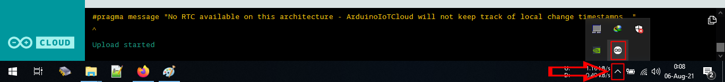

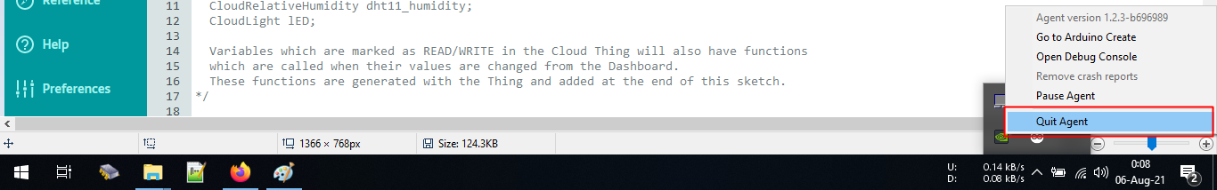
- Click the Arduino Create Agent icon, then the options menu appears, then click "Quit Agent".

- Then unplug the usb cable that connects the ESP32 with the computer.
- Run “Arduino Create Agent” again (Make sure Arduino Create Agent is run as Administrator), then plug in the ESP32 usb cable with the computer (connect the ESP32 with the computer).
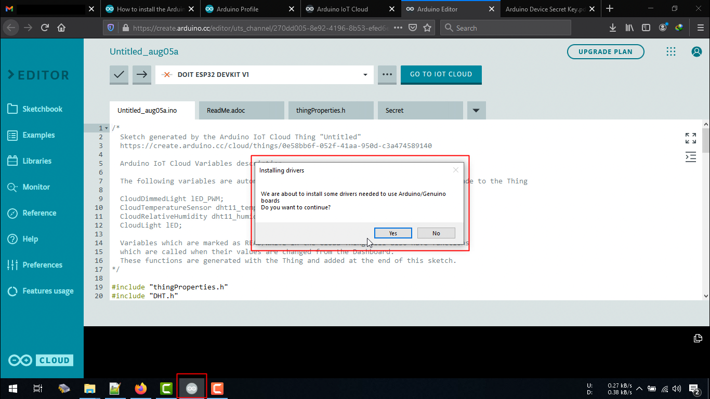
- Wait a moment, if the Arduino Create agent does not ask for "Installing drivers" as shown below, then repeat steps 1, 2, 3 and 4 until a display like the image below appears. If it appears the display as shown below, then click "Yes".

- Wait for about 2 minutes, then refresh Arduino Web Editor, then repeat steps 1,2,3 and 4. Then try to upload the program code from Arduino Web Editor to EPS32.
In my case, if I followed the steps above, then I successfully uploaded the program code. But after successfully uploading the program code about 3 times, then the next one will fail. Then I repeated steps 1,2,3 and 4 to be able to upload the program code again.
Honestly on this project, I'm using Arduino Web Editor and Arduino Create Agent for the first time, I've never used them before. "Maybe" the problems that I experienced as in the points above because I did the installation or settings that were not correct, I don't know for sure, and I continue to find out. If you are more experienced in using the Arduino Web Editor and Arduino Create Agent, please write a comment about a more appropriate solution in the comments section of this project video.

